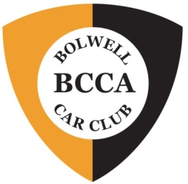
BCCA National Meeting 2024
Bundalong (near Yarrawonga), Victoria
Who'd like to join us?
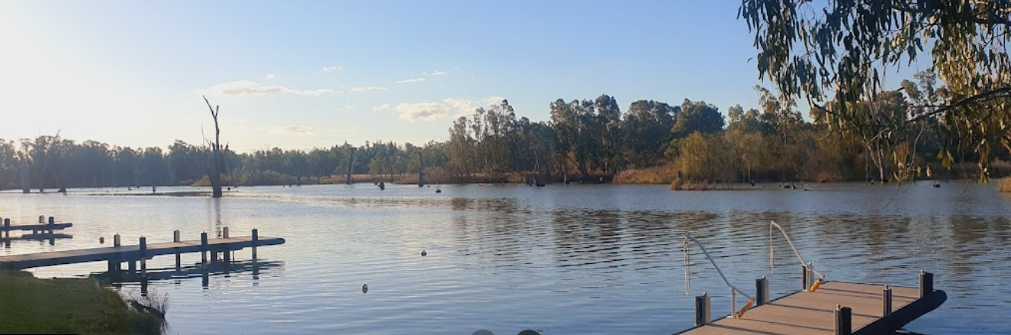

Hello BCCA Community!

BCCA VIC is organising the 2024 National Meeting which will be located in Bundalong near Yarrawonga. Whilst we're still working out the details, the following provides you with certainty about dates and allows you to start planning!

Dates: Friday 19th - Monday 22nd April 2024

Accommodation: Bundalong Villas & Tavern, Murray Valley Hwy, Bundalong
Choice of: 2 & 3 bedroom villas / Powered sites
Great local eateries
Easy trailer parking available for everyone

The schedule will be similar to the traditional format, ie Show & Shine (hopefully next to Lake Mulwala); Fun Run (designed to enjoy the best scones, jam & cream you've ever had whilst looking at painted silos and enjoying great roads); and a choice of the Wilby racetrack or local sightseeing.

$$$: Currently working on the details: hoping to advise you of approximate amounts before Christmas.
Full payment will be required by mid February 2024.

Attendance: If you could please let us know if you're interested, that will help with planning and costs. Please complete the attached EOI form by Friday, 17th November 2023.

Looking forward to seeing you there!

From the 2024 Easter Organising Committee:
Larissa Tipping, Rick Dathan, Vic Garra, Alan Harmer, John Hartney, Merryn Jackson, Paul Pettigrew, Ken Williams.
Easter 2024 – Bundalong, VIC
'Expression of Interest' form

I/We will be attending BCCA Easter 2024 at Bundalong:
Names (include age of any children)

Your Email contact details:

Please let us know the following:
Question | Answer
What car will you be bringing?
Do you / any of your group have any special dietary requirements? (Please provide details: who & what?)

Do you / any of your group have any other special requirements? (mobility, etc. Please provide details).

Please email the completed form by Friday, 17th November 2023 and email to Merryn Jackson:
merrynmjackson@gmail.com

